**ERASMUS+ Workshop 1 – Data in Our Hands (and Mobile Devices)   
DIRECTORS Session 2: Collecting and Analysing Mobile Device Usage Data**

Dear parents, in the second session we will use **mobile devices** – phones or tablets – as a tool to   
collect data, specifically **data about device usage**, which we can analyse and visualise.  
**PLEASE NOTE**: We are not focusing here on the issue of “excessive device use”; we are simply using this data as an example of real-world data familiar to children.

1) If your child does **not have a mobile device** (or does not share one), don’t worry!  
 Your child will work together with someone else during the workshop.  
  
2) If your child **has a mobile device** (or shares one), please check that   
**daily usage tracking** (how much time is spent on each app, etc.) is enabled on the device   
**at least a few days before the workshop**.  
Instructions for enabling this feature can be found on the following page.

3) **Together** with your child, please **check the mobile device usage tracking**and **fill in the following table.** Choose any of the previous days (it can be a weekend or a weekday).

Date of completion (data tracking): ____________________________

* Most used **games** on that day:
  + How many minutes were the games used that day (add up the minutes for each individual game) _________
  + How many times were the games opened that day (add up the openings for each individual game) _________
* Most used **video applications** (e.g., YouTube) on that day:
  + How many minutes were the video apps used that day (add up the minutes for each individual app) ________
  + How many times were the video apps opened that day (add up the openings for each individual app) ________
* Most used **chat applications** (e.g., WhatsApp, Viber) on that day:
  + How many minutes were chat apps used that day (add up the minutes for each individual app) _________
  + How many times were chat apps opened that day (add up the openings for each individual app) _________
* **Mobile phone use** in general:
  + How many minutes was the device used that day _________
  + How many minutes was the device picked up/unlocked that day _________

**PLEASE NOTE**:   
Please check if your child needs to bring the mobile device to the workshop!

Please, turn the page!

**THANK YOU FOR YOUR HELP!**

**Instructions for viewing and enabling daily device usage tracking:**

* ***Android*** devices:
  + *Digital Wellbeing*app -> *Manage your data* ->  
    enable *Daily phone usage* tracking  
    (available on Android devices version 9 and above).  
    If you don’t see this icon, go to *Settings* -> *Digital Wellbeing & parental controls*.

* ***iPhone*** devices:
  + Application *ScreenTime* -> *Settings* -> *Screen Time*, choose *App & Website Activity* ->  
    *Turn On App & Website Activity* -> *See All App & Website Activity* -> *Devices*   
    to select the device for which you want to view usage data.  
    Choose *Week* to display a weekly usage summary,  
    or *Day* to display a daily usage summary.

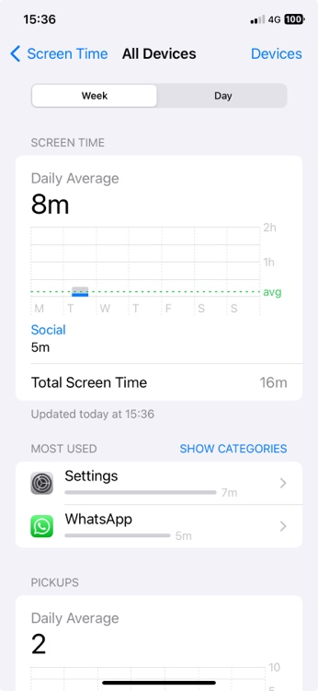

* + If these options are enabled, you can view daily or weekly data by app or category.  
    Go to *Settings* -> *Screen Time* -> *See All Apps & Website Activity*. A daily summary will be displayed.  
    As you scroll down, you’ll see the number of device pickups and notifications.  
    By selecting a specific app, you’ll see a summary of its usage.

