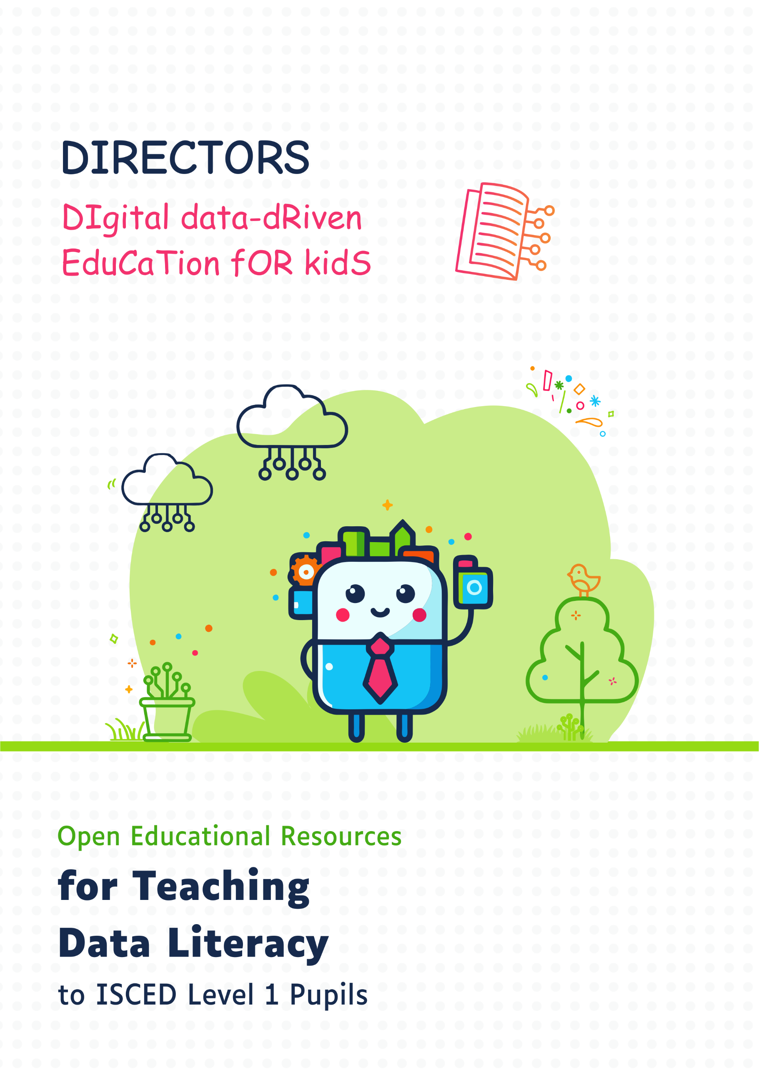

Version: 20250708



Digital and data literacy are crucial today, especially for younger generations. The **[DIRECTORS (DIgital data‑dRiven EduCaTion fOR kidS)](http://www.kidsdirectors.eu)** focuses on **promoting data literacy in primary education** through innovative teaching methods and materials. The project is implemented by the University of Zagreb in Croatia and the Delft University of Technology in the Netherlands, as part of the Erasmus+ programme co-funded by the European Commission.

As part of the DIRECTORS project, we developed **three workshops** for lower primary education (ISCED level 1), each consisting of two sessions. The workshops are structured around three levels of data literacy, with each level tailored to the age and prior knowledge of the pupils. Workshop 1: **Data in Our Hands (and Mobile Devices)** introduces basic data skills; Workshop 2: **Geospatial Data (and Maps) in Our Hands** targets intermediateskills; Workshop 3: **Data Sources** encourages the development of advanced data literacy.

Each workshop includes two sessions, and each session consists of two 45-minute school periods. The activities are carefully designed to offer pupils hands-on experience through “learning by doing,” enabling them to apply the acquired concepts in real-world contexts and covering the **entire data cycle** — from (1) data collection carried out by the pupils in their own environment, through (2) data processing in a “child-readable” format with error checking and cleaning if needed, (3) data analysis by asking questions and drawing insights, (4) data visualization to support clear communication and spatial thinking, to (5) critical reflection and interpretation, drawing conclusions both from the data and about the data itself.

In the first session of each workshop, pupils engage with the material offline, using manual methods. In the second session, the same content is transferred to an online environment using digital technologies. The workshops are based on an interactive and practical approach that actively involves pupils in working on concrete tasks.

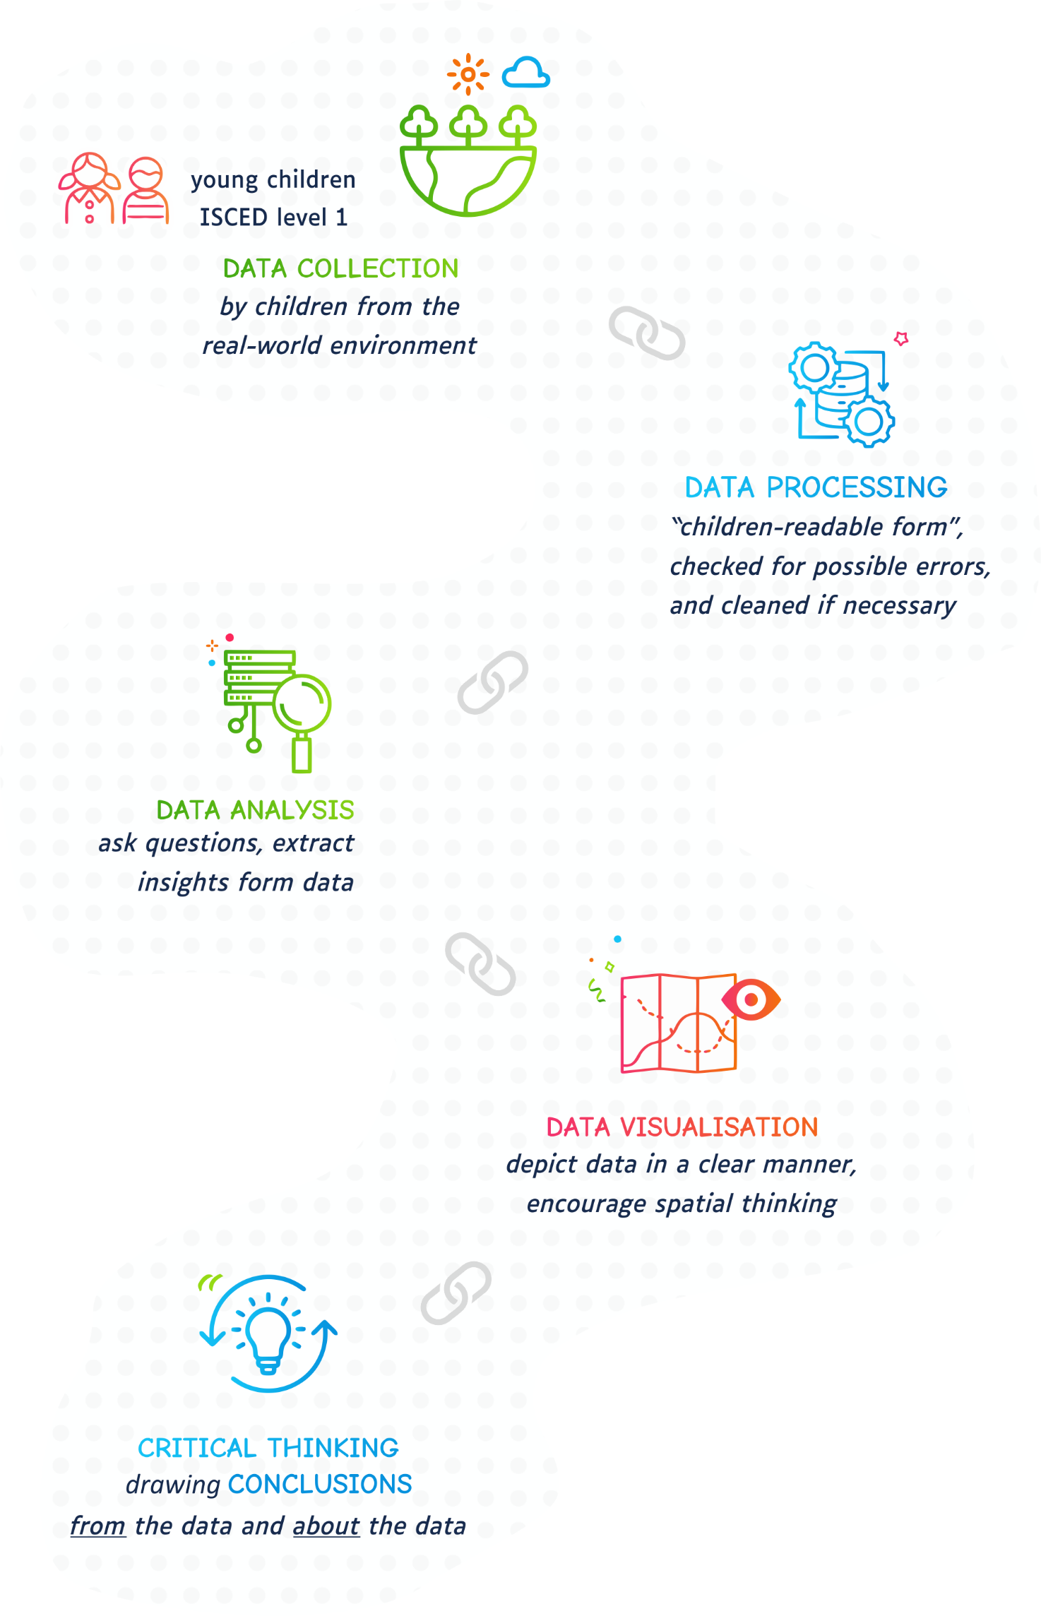



**WORKSHOP 2**

**Geospatial Data (and Maps) in Our Hands**Ana Kuveždić Divjak, Bastiaan van Loenen, Ivana Bosnić, Frederika Welle Donker

You are viewing the educational materials for implementing **Workshop 2**: Geospatial Data (and Maps) in Our Hands, **Session 1**: Smart Maps in Action – Trace, Overlay and Discover! All materials are also available on the website of the DIRECTORS project: [www.kidsdirectors.eu](http://www.kidsdirectors.eu).

Workshop 2: Geospatial Data (and Maps) in Our Hands introduces pupils to the **world of geoinformation and geospatial data mapping**.

In the *first* session, pupils will learn the basics of Geographic Information Systems (GIS) by creating map layers on transparent sheets. Using an orthophoto as a base map, they will accurately trace objects from the school surroundings onto separate transparent layers, visually representing the layered structure of space and the core principle behind GIS. Each sheet will represent one layer of information – such as buildings, trees, roads, or playgrounds. When overlayed, these sheets will form a complete map, providing a simple visual analogy for how GIS works. Just as the transparent sheets represent different layers, GIS systems digitally organize and analyse spatial data in layers, enabling the exploration of various elements of space.

In the *second* session, pupils will apply their knowledge in a digital environment by participating in a detective-style treasure hunt. Using GIS layers and data in digital form, they will solve puzzles step by step. The detective game will conclude outside the classroom, as pupils follow geographic coordinates obtained during the puzzle-solving process.

[DIgital data dRiven EduCaTion fOR kidS](http://www.kidsdirectors.eu) I Open Educational Resources for Teaching Data Literacy to   
ISCED Level 1 pupils I Workshop 2: Geospatial Data (and Maps) in Our Hands by Ana Kuveždić   
Divjak, Bastiaan van Loenen, Ivana Bosnić, Frederika Welle Donker is licensed under [CC BY 4.0](https://creativecommons.org/licenses/by/4.0/)



**WORKSHOP 2**

**Geospatial Data (and Maps) in Our Hands**Session 1: Smart Maps in Action: Trace, Overlay, and Discover!

🗺️🧠 ✨🔍



1. Required Materials and Preparatory Activities

* A computer with internet access and a projector or smartboard.
* Overhead projector transparencies (three per pupil team).
* Permanent markers (one per pupil).
* A template with cartographic symbols, a north arrow, and a graphic scale   
  (available on the project website [www.kidsdirectors.eu](http://www.kidsdirectors.eu)).
* A printed orthophoto map showing the school’s surroundings.
* Compass, ruler, scissors, and glue stick.

1. Basic Information About the Topic

This workshop introduces pupils to the world of maps and Geographic Information Systems (GIS), teaching them how to create maps that can be understood by both humans and computers. Through engaging activities, pupils will learn fundamental cartographic and GIS concepts such as georeferencing, vectorization, scale, orientation, and symbolization, and they will explore the differences between raster and vector data. By the end of the workshop, pupils will have gained the skills to create “smart” maps, helping them navigate their surroundings and solve real-world problems.

1. Lesson Organisation

The table below outlines the structure of the lesson, with approximate durations for each activity. Since the activities are flexible, in some cases multiple **options or variations** are offered. Certain activities may also include additional elements (marked as “EXTRA”), such as extended discussion points. The estimated duration of each activity is shown as a range. The actual time needed may vary depending on the pupils’ age and prior knowledge.

| Activity | Duration (minutes) | Method | Description |
| --- | --- | --- | --- |
| Introduction | 5 | Whole-class discussion | Introduction to the topic of “maps” using a fun example. |
| Connecting to the School’s Surroundings | 5-10 | Whole-class discussion | Identifying features on the orthophoto map: your school, the school playground, your home building, local shops, and other landmarks. |
| Let’s Make a Map – Georeferencing | 10 | Individual / Teamwork | Georeferencing a raster image (orthophoto map). |
| Let’s Make a Map – Vectorization | 10-25 | Individual / Teamwork | Vectorizing buildings and streets (optionally also trees, water features, and other objects). |
| Let’s Make a Map – Map Design | 25 | Individual / Teamwork | Finalizing the map: scale, north orientation, symbolization, legend. Pupils combine the individual map layers into a single large map. |
| Analysis and Discussion | 15 | Whole-class discussion | Discussing the created maps, comparing individual vs group results: similarities and differences. |
| Conclusion and Reflection | 5 | Whole-class discussion / Individual work | Pupils summarize what they did and learned. The teacher introduces a visual analogy with GIS: just like transparent sheets represent different layers, GIS systems digitally organize and analyse data in layers, enabling the exploration of different spatial elements. |
| Total | 75-95 |  |  |



1. A group of sausages on a black background

   AI-generated content may be incorrect.Learning Outcomes

4.1 Learning Outcomes – Teacher Language

By the end of this lesson, the pupil will be able to:

* Identify basic concepts related to maps, layers, and symbolisation, including what a map is and how GIS uses layers to represent spatial data.
* Explain the differences between traditional paper maps and maps in a GIS, and describe how georeferencing helps to place a map in the correct location, i.e., aligning it with real-world coordinates.
* Apply georeferencing techniques by aligning transparencies with a base map and create different layers representing buildings, roads, trees, etc.
* Analyse how different layers (e.g., roads, buildings) interact when combined into a complete map and explain the importance of correct alignment of these layers.
* Evaluate the map they created and those created by peers, discussing how accurately they represent real-world features and relationships, and how understandable the map is to a computer.
* Create a layered map using transparencies, add a graphic scale and a north arrow, and design a legend that explains the symbols and colours used on the map.

4.2 Learning Outcomes – Pupil Language

You'll *discover* what maps are and how we use them to find places and learn about the world around us. You'll *understand* the difference between regular paper maps and special smart maps (GIS) that computers use. You'll *learn* how to put maps in the right place using a simple trick called "georeferencing." You'll *create* your own map using transparencies to show things like roads, buildings, and trees, just like a computer does with smart maps. You'll *see* how different map layers fit together and explore why it's important for them to be in the right spot. You'll *create* a full map with symbols, a scale to show distances, a north arrow for direction, and a legend to explain what the symbols and colours on your map mean.

1. A group of sausages on a black background

   AI-generated content may be incorrect.Fun Facts

Using these fun facts is optional – their inclusion depends on the pupils’ age and the teaching context. You can include them as you see fit, choose just a few, or skip them entirely. It's recommended to use those that are most relatable to the pupils' own experiences and surroundings.

Did you know that the first maps were made almost 25,000 years ago? But they weren’t drawn on paper or made on a computer. Instead, people carved them into mammoth tusks! One of the oldest known maps, found in the Czech Republic, shows a river and paths leading to a hunting ground. ([source](https://upload.wikimedia.org/wikipedia/commons/f/f2/Engraving_on_a_mammoth_tusk%2C_map%2C_Gravettian%2C_076872.jpg)).

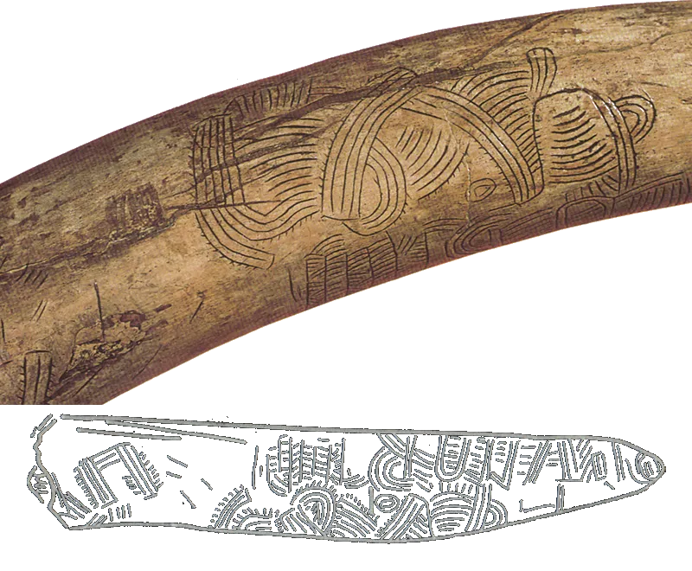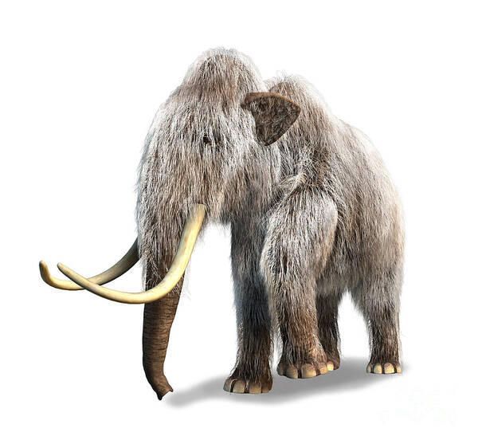

Did you know there’s a super tiny map of the world? In 2012, scientists in Zurich created the smallest 3D map ever – it’s so small that 1,000 of them could fit on a single grain of salt! They used a special tiny machine and an ultra-thin needle to make it ([source](https://education.nationalgeographic.org/resource/worlds-smallest-map/)).



You’ve probably seen treasure maps in books or movies, but guess what? Real pirates didn’t actually use maps to hide their treasure. Still, who knows – maybe you will discover some hidden treasure somewhere near your school. ;)

When you use **Google Maps** (specifically, the Google Traffic feature that shows real-time traffic conditions) to find the best route, the app checks where other vehicles are – kind of like how ants “communicate” when they’re searching for food! Ants leave behind a special scent called a pheromone, which is why we often see them walking in a straight line. Google Maps “talks” to other cars in a similar way to help you find the fastest route – just like ants finding the shortest path to food!



**Paper maps are still super useful – especially when there’s no internet!**Even though we have all kinds of technology today, paper maps can still save the day when it really counts. Imagine being somewhere with no internet or your phone stops working – that’s when knowing how to read a map becomes a real superpower that can help you find your way!

1. A group of sausages on a black background

   AI-generated content may be incorrect.Activity Flow

6.1 Introducing the Topic

* Start with the questions: “*What is a map? Why do we use maps?*”
  + A **map** is a picture or drawing of an area that shows different features like roads, buildings, rivers... A map helps us find our way and understand where things are. It shows us how to get from one place to another.
    1. Discussion – A Map from an Imaginary World

Begin the conversation about maps with a fun example. Show the pupils a map from the popular video game *Super Mario Bros* ([source](https://x.com/KokiriCraig/status/1468342988849963015)). In that game, each level is like a separate map showing the path Mario needs to take to reach his goal. These maps aren’t just fun, they’re full of secrets and challenges that players have to discover!

* “Take a look at this map from the video game *Super Mario Bros* – what do you notice?”
  + Encourage pupils to share their thoughts freely and point out any characters, castles, or obstacles they spot.
* “What might this map be used for?”
  + Start a discussion about how the map helps the player. Ask questions like:   
    “**Where** should Mario go next?”, “How can you tell **where** the dangers are?”

**Conclusion**: This map helps players find their way through the game – it shows them where to go and what obstacles to avoid. Just like in video games, maps help us understand the space around us in real life. Similarly, when we want to navigate the real world, we use a city map. A city map is a large-scale thematic map of a city that shows streets, squares, parks, buildings, and other important features. Just like Mario uses his map to reach his goal, we can use a city map to help us get where we need to go.

* + 1. Connecting to the School’s Surroundings – Orthophoto Map

Let’s take a look at an orthophoto map of the real world. An orthophoto map is an aerial (or satellite) photograph that has been georeferenced and photogrammetrically corrected, meaning it has the properties of a map – it shows the correct scale and known coordinates – so it can be used as an accurate cartographic base.

Explain to pupils that an orthophoto map is a photo taken from above – by an airplane, drone, or satellite. Experts then “correct” the photo so it looks like it was taken exactly from above. Everything is in the right place: every point in the image has its own coordinates – like an address on Earth. The scale is also accurate, which means distances and areas can be measured just as reliably as on a regular map.

Open the official geoportal of your country – this is usually a national online platform that provides access to various map layers and geographic data. Look for the most recent orthophoto layer (aerial or satellite imagery corrected to match the properties of a map), and use the search function to enter your school’s address. Once the map zooms to the correct location, slowly zoom in until the school buildings, streets, and surrounding area are clearly visible on the screen. Then, show this view to the pupils so they can explore an orthophoto map of their own environment. If you're based in Croatia, you can use the Geoportal of the State Geodetic Administration (geoportal.dgu.hr).

* Carefully observe the orthophoto map. “Do you recognize the area shown? How can this map help us? How is it different from the map in the Super Mario game?”
  + Encourage pupils to comment spontaneously and to identify the school, school playground, their building, and other objects in the neighbourhood.
* What can this map tell us? How is it different from a map of an imaginary world? How can this map help us?
  + Ask pupils questions such as: “How would you use this map to find the fastest way from your school to the playground?” or “Can you estimate the distance from your building to the nearest park just by looking at the aerial image?”
    1. Discussion

Now that we’ve learned what an orthophoto map is, let’s think about the following: does a computer understand such a map in the same way you do?

* Think about how easily you can recognize the objects shown (e.g. a school, playground, shop…). Can a computer do the same?
* Can a computer recognize my school or find the nearest park just based on an aerial image?
  + Encourage pupils to consider that computers only see raw data (like an image) and that they need additional information in order to “understand” what that data represents.
* Can a computer calculate the shortest route from school to my home?
  + This encourages them to think about how computers need additional data layers, such as road networks, in order to make decisions.

*This discussion helps introduce the concept of GIS and “smart maps,” highlighting the difference between human and computer interpretation of visual information.*

* + 1. What is GIS? Understanding Smart Maps

A **Geographic Information System (GIS)** is a computer-based system that allows for the collection, storage, viewing, analysis, and presentation of data related to specific locations. Such systems are used in many fields – from cartography, geodesy, ecology, and urban planning, to navigation, statistics, and national and local government.

The easiest way to explain GIS to pupils is to call it a “smart map.” Unlike a regular paper map that only shows where something is (such as streets, buildings, or parks), a GIS map can show much more, like:

* + where the nearest shop is,
  + the fastest route to the playground,
  + the best place to plant a tree,
  + or how traffic affects air pollution.

**How does GIS work?** Imagine that each type of data is a separate layer – one layer shows roads, another houses, a third one greenery. When we stack them on top of each other, we get a layered map. GIS can then “read” these layers together and answer various questions, such as: *“What’s the fastest way to school?”* or *“Where is the nearest park?”*.

GIS is special not just because it shows where things are, but because it helps us understand how different parts of a space are connected – and why something is located where it is.

During the explanation, show pupils a slide with an illustration of layers (orthophoto, streets, houses, parks…). The presentation is available on the project website.A cartoon character standing on top of a computer monitor

**GIS**

## 6.2 Task: Let’s Make a Map!

* Divide pupils into teams; we recommend two pupils per team.
* Give each team a printed orthophoto map showing the area around the school (downloaded from the project website), and give each pupil a permanent marker.
* **OPTIONAL:** Prepare an orthophoto map showing the surroundings of your school. Instructions on how to do this using the Geoportal of the State Geodetic Administration of the Republic of Croatia (geoportal.dgu.hr) are available on the project website.

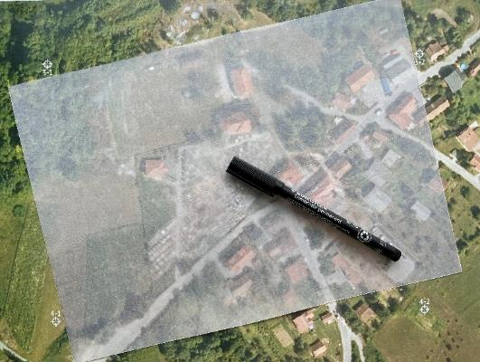

6.2.1 Precise Alignment of Map Layers – Georeferencing

You will place the orthophoto map as the first, base layer of your map. It will serve as the foundational background over which you will collect spatial data by carefully tracing selected features onto transparent sheets.

Before tracing, each transparent sheet must be **georeferenced**.

* + **Georeferencing** is the process of assigning geographic coordinates – or rectangular coordinates (Cartesian coordinates) in a specific map projection – to particular points of an object. Simply put, it means placing the map in the correct position using coordinates.

Instructions for pupils:

* Carefully place the transparent sheet over the orthophoto map so that all alignment marks (crosshairs) appear in the corners of the sheet.

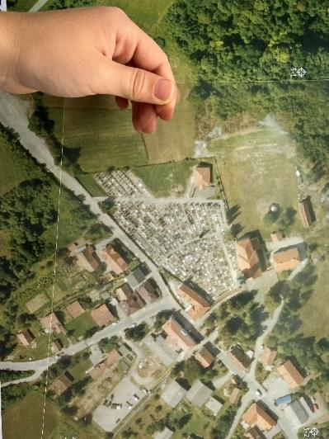

* Then, trace the alignment marks (crosshairs) onto the transparent sheet. This ensures that every object you draw afterward will be correctly positioned in relation to the real-world space.

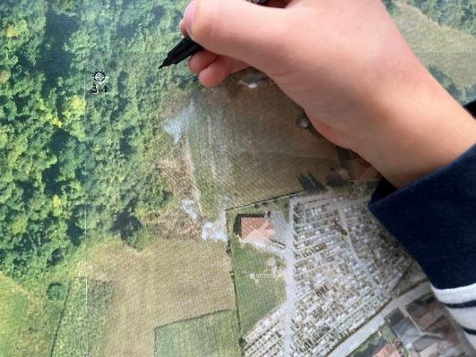 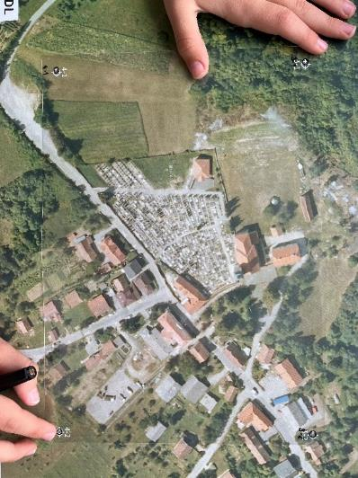

6.2.2 Data Collection – Vectorization

The next step in map-making is **vectorization**.

* + Vectorization is the process of converting an image made up of a grid of pixels (raster) into a set of points, lines, and polygons (vector). This way, we create precise, measurable objects that a GIS can analyse and combine with other data layers.

Instructions for pupils:

* Layer: BUILDINGS
  + Place the georeferenced transparent sheet over the orthophoto map. Make sure all alignment marks (crosshairs) match up perfectly – this is the only way to ensure that the drawn layer will later align correctly with the rest of the map.
* Using a fine black marker, carefully and neatly trace all the buildings you can see: residential houses, the school, hospital, church, shops, shopping centre, etc. Try to follow the edges of the buildings as accurately as possible.

* **OPTIONAL**: Once you’ve finished outlining all the buildings, you can – if you wish – add colour to make their functions immediately recognizable. For example, colour residential houses white, the school orange, the church purple, and so on. The colours can be different; what matters is that each type of building has its own distinct colour. This way, you emphasize the differences in purpose between residential, public, and commercial buildings, making your map layer clearer and more informative.

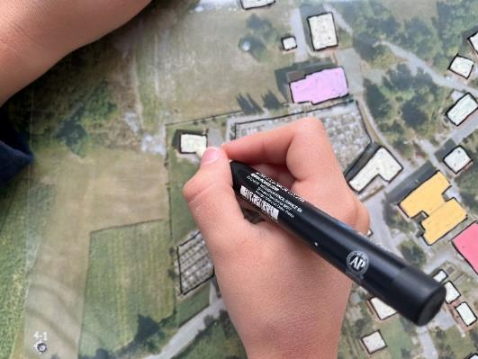

* Layer: STREETS
  + Carefully place the transparent sheet over the orthophoto map so that all alignment marks (crosshairs) appear in the corners of the sheet. Then trace those marks onto the sheet. This ensures that the street layer will match the real-world position.
  + Using a permanent marker, draw two parallel lines along each visible transportation corridor on the orthophoto map (main and side streets, access roads, parking lots).
  + If the road is very narrow (e.g. a pedestrian path), a single line representing its central direction is enough.
  + Label each street by writing its name directly next to the drawn street. Make sure the text is parallel to the road’s axis and does not cover other important features.
  + Carefully overlay the street layer with the building layer using the alignment marks (crosshairs).

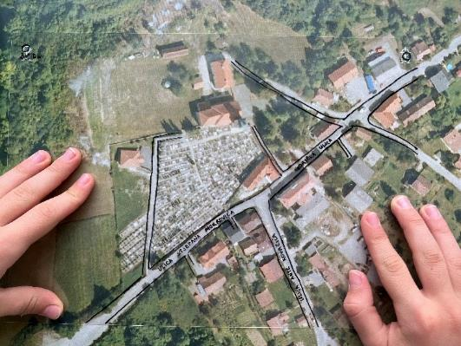 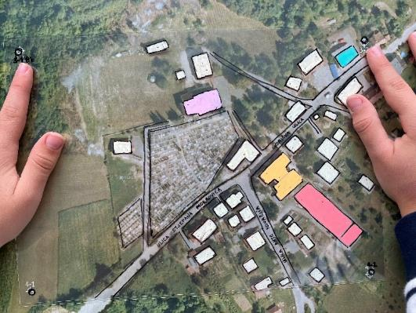

**Option 1**: Basic version.   
Draw only two thematic layers: (1) buildings – carefully trace the outlines of all structures, and (2) streets/roads – draw the edges of all visible roads, and if you wish, add the street names.

This basic version is enough to understand the core concept of vectorization and layered data representation. It requires less time and fewer materials (sheets).

**Option 2**: Advanced version.   
The map can include more than two layers. In addition to buildings and streets, add as many extra layers as you like, depending on the features found in the area around your school. Examples of possible layers: green spaces (parks, lawns), individual trees or tree rows, water bodies (streams, canals, ponds), etc. Each additional layer should be drawn on a separate transparent sheet, and remember to georeference the sheet before drawing. This version requires more time and precision, but it results in a richer “smart” map that clearly shows how different elements of the space are interconnected. **A cartoon of a person
**

6.2.3 Final Map Design

The final layer of the map is created on a third transparent sheet, which is used to add elements essential for correctly reading the map. On this sheet, pupils will attach or draw components such as a graphic scale, a north arrow, and map symbols with a corresponding legend. Pupils cut out these elements – scales, arrows, and pre-designed map symbols – from the provided template. This template, along with additional versions containing an extended set of symbols, is available on the project website.

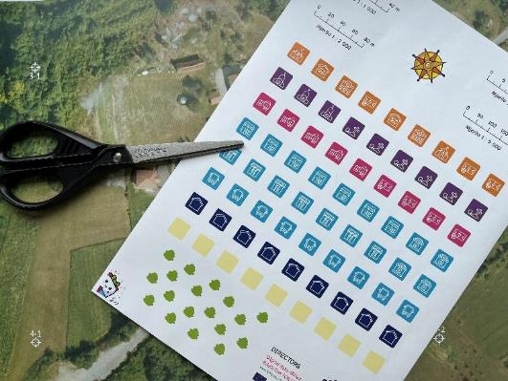 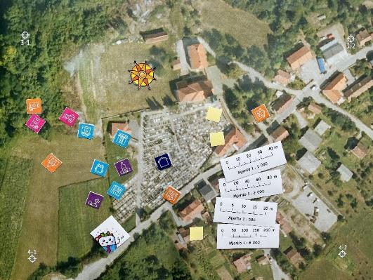

* Graphic scale
  + Pupils begin by using a ruler to measure the length of a known object on the orthophoto map – for example, the front of the school building – and then estimate the same distance in real life. They can also use the digital “Measure Distance” tool on the Geoportal.
  + By comparing the measured values, they calculate the scale ratio and select the graphic scale from the provided options that best matches their map.

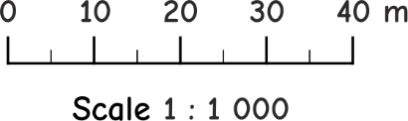 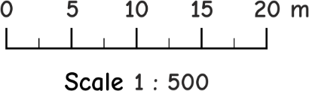 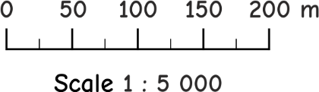

* + The chosen scale is then carefully glued to the bottom edge of the map.
  + The teacher leads a class discussion about the meaning of the scale notation, for example, 1 : 1,000 (which means that 1 centimetre on the map represents 10 meters in real life), and emphasizes the importance of scale for correctly reading the map and accurately estimating distances.



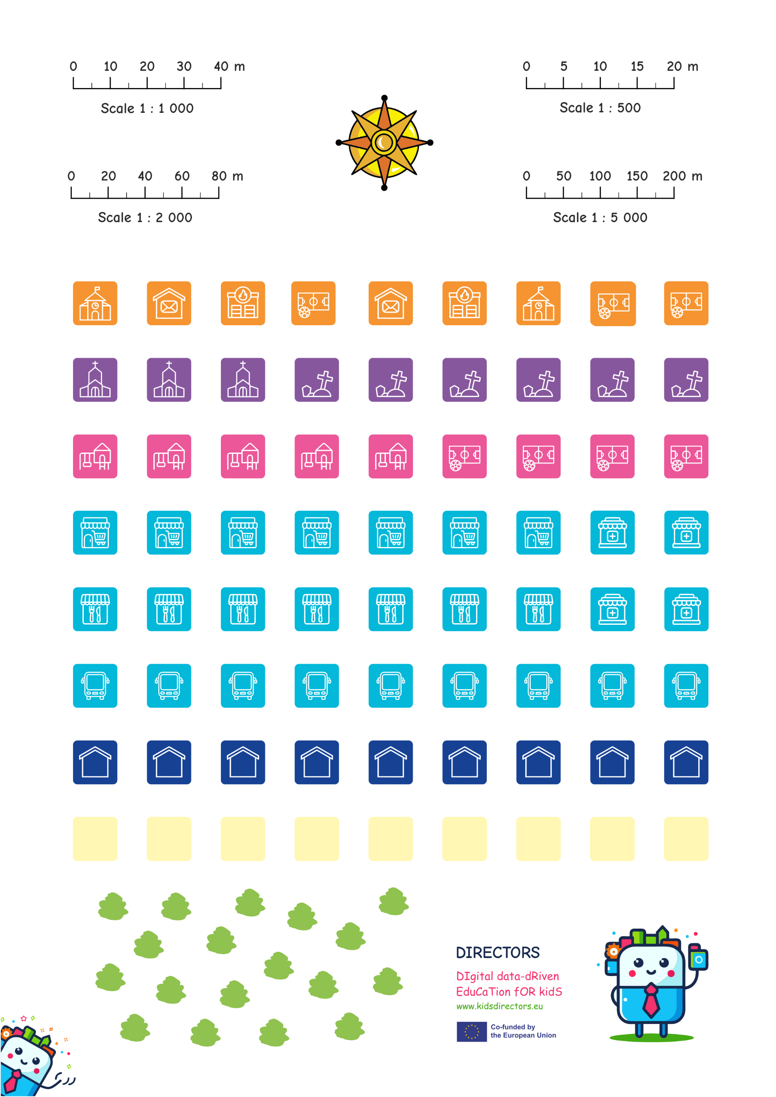

* North direction
  + Using a compass, determine the direction of north together with the pupils in the classroom.
  + Pupils cut out the north arrow from the provided template and place it at the top edge of the transparent sheet, making sure the arrowhead points toward true north.

Explain to pupils that in cartography, north is almost always shown at the top of the map and is generally assumed to mean “up.” However, without a clear north indicator, we cannot be sure if the map is correctly oriented—which is essential for accurate reading and interpretation.



* Map symbols and map legend
  + Identifying objects in the surrounding area:   
    Together with the teacher, pupils list all recognizable objects located near the school. These might include, for example: a shop, kindergarten, hair salon, dog park, post office, restaurant, café, bus stop, playground, etc.

* + Choosing map symbols:   
    For each listed object, pupils either select a suitable cartographic symbol from the template or create one themselves (e.g., a small square with a red cross to represent a pharmacy).
  + Placing symbols on the map: Each selected cartographic symbol is placed precisely at the location of the corresponding object on the previously created vector layers. The symbol is then carefully glued in place using a glue stick. Pupils should make sure that the symbol does not cover any important information.

* + Creating the legend: On the edge of the same transparent sheet – or on a separate smaller sheet – pupils create a legend. For each symbol used, they write a brief explanation of its meaning (e.g., shop, hairdresser, dog park). This helps users of the map easily understand what each symbol represents.

By adding map symbols and a legend, pupils complete the process of making a “smart” map. Their map now not only shows *where* things are, but also *what* is located at that particular location – making it clear, informative, and easy to understand for everyone.

Once the graphic scale, north arrow, map symbols, and legend are finished, this final transparent sheet is placed over the previously vectorized layers (buildings, streets, and any additional thematic layers). This creates a complete “smart” map that includes:

* + space (orthophoto – base map, raster layer,
  + objects (buildings, streets – vector layers),
  + orientation and scale (north arrow and graphic scale), and
  + a key for reading a map (legend with map symbols).

6.3 Analysis and Discussion

Each team brings their completed transparent sheets and, using the alignment marks (crosshairs), carefully assembles them like a mosaic. This creates one large map of the school surroundings, made up of all the individual pupil maps.

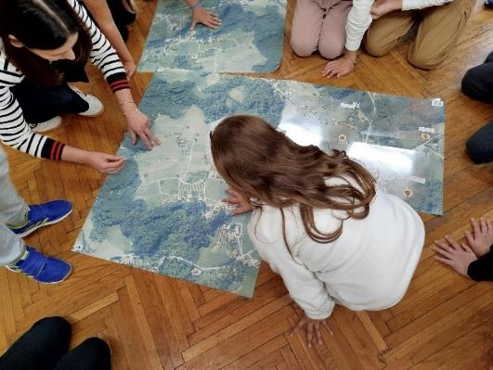 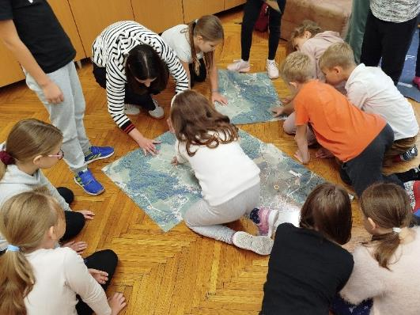

* Guided discussion  
  To encourage critical thinking, teachers may ask the following questions:
  + “What do you think of your classmates’ maps?”  
    Pupils recognize different approaches and ideas.
  + “Which map do you think is the best, and why?”  
    A discussion develops around objective criteria such as accuracy, neatness, and completeness.
  + “Which map looks the most visually appealing to you? Explain.”  
    Pupils learn to distinguish between aesthetic appeal (colours, symbol layout) and technical quality.

The goal of this activity is for pupils to recognize the differences between maps and collaboratively define standards for quality cartographic design. These insights will serve as a foundation for future projects – especially in digital environments when working with GIS.

6.4 Conclusion and Deepening the Learning

After pupils have assembled the “big” map made up of multiple layers, it's important to clearly and simply connect their hand-drawn layers to the concept of a digital Geographic Information System (GIS). This completes the process – from the orthophoto map as the base layer (raster), through the thematic layers drawn by the pupils (vectors), to the GIS as a computer system that organizes, analyses, and visually displays all those layers.

* What have we achieved?
  + Georeferencing – Pupils learned why the placement of alignment marks (crosshairs) matters and how each sheet must “fit” exactly in the right place.
  + Vectorization – Pupils converted a photographic base (raster) into thematic vector layers (buildings, roads, green spaces…).
  + Map symbols – Pupils developed a system of symbols and colours that allows the map to communicate clearly – without the need for long descriptions.
  + Critical analysis – Pupils compared maps made by their peers, discussed different solutions, and jointly defined the criteria for good map-making practice.

Conclude the discussion with a brief summary: When we overlay all the layers, we get an “analog GIS map” – just like in a computer, but on transparent sheets.

* Connection to GIS
  + Data types  
    Orthophoto = raster; transparent sheets = vectors. In a computer, rasters and vectors are stored in files such as GeoTIFF, Shapefile, or GeoPackage.
  + Layers  
    In GIS software (e.g. QGIS), layers can be turned on or off, added or removed—exactly like pupils did manually with the transparent sheets.
  + Attributes  
    The map legend explains the symbols linked to features on the map. In GIS, this is done through an attribute table (e.g. a column saying “type = residential”).
  + Analysis tools  
    What pupils measured manually with a ruler (distance, area), GIS calculates automatically. It can also generate buffer zones, determine the shortest route, or analyse traffic density.
* Ideas for deepening  
  Spatial planning scenarios – focus on planning and sustainability. For example: “Where is the best place for a new playground?” Pupils apply real-world criteria (distance from houses, safety, existing green space) to make informed decisions.

**Takeaway message**: Your analogue project already functions like a small GIS. Moving into a digital environment brings speed, accuracy, and analytical power—but the core principles remain the same: raster, vector, layers, symbols, and legend.

Co-funded by the European Union. Views and opinions expressed are however those of the author(s) only and do not necessarily reflect those of the European Union or the European Education and Culture Executive Agency (EACEA). Neither the European Union nor EACEA can be held responsible for them.   
[[Erasmus+ Project 2023-1-NL01-KA210-SCH-000157821 DIgital data-dRiven EduCaTion fOR kidS](https://erasmus-plus.ec.europa.eu/projects/search/details/2023-1-NL01-KA210-SCH-000157821)]

The **DIRECTORS (DIgital data-dRiven EduCaTion fOR kidS)** project is carried out by partners from Delft University of Technology (The Netherlands) and the University of Zagreb (Croatia) as part of the Erasmus+ programme, co-funded by the European Commission.

Our goal is to **promote data literacy in primary education** through new teaching methods and materials. We aim to support the updating of existing curricula related to data education, with the goal of enhancing digital and data skills among **teachers and pupils**.

These open educational resources are the result of the DIRECTORS project’s commitment to strengthening data literacy among young primary school pupils, offering **practical and age-appropriate** open content designed for both teachers and learners.

[**www.kidsdirectors.eu**](http://www.kidsdirectors.eu)