**ERASMUS+ Workshop 3 – Data Sources  
DIRECTORS Session 1: From Our Bodies to Sensor Technologies**

Dear parents, as part of the Session 1 of Workshop 3, we will be using **mobile devices and fitness trackers / smartwatches** to count steps and compare different methods of data collection.

1) If your child **does not own** (or share with someone) a **mobile device or a fitness band / smartwatch**, don't worry! They will be able to join someone else during the session.

2) If your child **owns a fitness tracker or smartwatch** (a device worn on the wrist   
that can count steps), please ensure they bring it with them on the day of the session.

3) If your child owns (or shares) a mobile device,  
  and you **agree with bringing it to school on the day of the workshop,**  
  please **check in advance** whether the device counts daily steps.  
  Most mobile devices already have a built-in app for this – there is no need to install anything.  
  Just make sure that step counting is enabled in the app at least two days before the session.

Please also **explain to your child how to open the step-counting app**.

Below are instructions on how to check or enable step counting in these apps:

* **Android** devices: if the app is already installed, it should already be tracking steps –   
  there’s no need to enable anything.
  + *Google Fit* app

* + A screenshot of a phone

    Description automatically generatedA logo of a person

    Description automatically generated*Samsung Health* app (for *Samsung* mobile phones)

* **iPhone** device: Please, turn the page!

**THANK YOU FOR YOUR HELP!**

* iPhone devices: (1) Open ***Settings*** on your *iPhone*.  
   (2) Select ***Privacy***.  
   (3) Tap on ***Motion & Fitness***.  
   (4) Turn on ***Fitness Tracking***.  
     
    
  A screen shot of a cell phone

  Description automatically generated A screenshot of a phone

  Description automatically generated A screenshot of a phone

  Description automatically generated A screenshot of a phone

  Description automatically generated
* There are two ways to view the step count:
  + Using the *Fitness* app:

open the *Fitness* app, select *Summary* -> *Activity*,  
 where you can see the number of steps per day, week, and month.

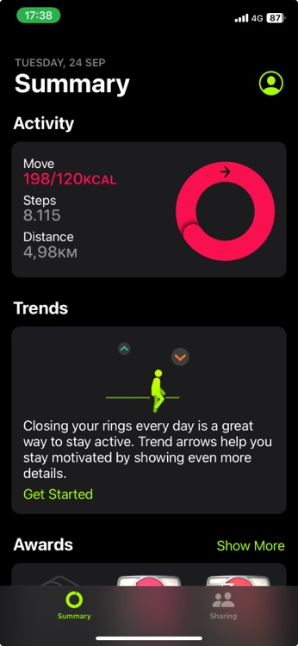

* + Using the ***Health*** app:  
    Depending on your *iPhone* version, select either ***Summary*** in the top right corner,  
    or select ***Steps*** directly from the ***Activity*** section.  
    If needed, choose ***Edit Favourites*** to display the desired activity  
    (in this case, ***Steps***), then select ***Done***.  
    In the ***Summary*** window, tap ***Steps*** to view detailed step count information.  
     **A heart shaped red and pink symbol

    Description automatically generated** 