ERASMUS+ Workshop 3 – Data Sources
DIRECTORS Session 1: From Our Bodies to Sensor Technologies
Two simple experiments you can try before our next session… Choose AT LEAST ONE!

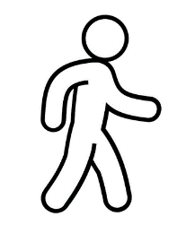
Experiment 1: WALKING WITH A MOBILE PHONE OR SMARTWATCH
- Choose a route to walk: from home to school, around the park...
- Count your steps in one direction, then in the opposite direction.
- Write down the numbers.
Number of steps in one direction: _______________
Number of steps in the opposite direction: _______________
- Is there a difference between the two numbers? Why do you think this happened?
__________________________________________________________________________



- If you have a mobile phone or a fitness tracker,
also write down the number of steps these devices counted.
Steps counted by the device (one direction): _______________
Steps counted by the device (opposite direction):: _______________
- Are these numbers higher or lower than your manual count? _______________
Why do you think that is so? _________________________________________________
- Would there be a difference if your hand was on a handle or steering wheel
(e.g. riding a balance bike, pushing a pram or a shopping trolley)?
________________________________________________________________________________
- Do you have any additional comments?
Did anything unusual happen during your measurements?
________________________________________________________________________________
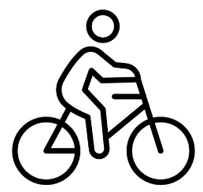
Experiment 2: CYCLING WITH A MOBILE PHONE
- Choose a route for your bike ride: from home to school, around the park...
- Measure how many "steps" your mobile phone recorded during this journey.
If you can, for one trip keep the phone in your pocket,
and for the other, in your bag.
- Write down the numbers.
Number of "steps" recorded during the bike ride in one direction: _______________
My phone was in: _______________
Number of "steps" recorded during the bike ride in the opposite direction: _____________
My phone was in: _______________
- Is there a difference between these numbers? Why do you think this happened?
___________________________________________________________________________

- Do you have any additional comments?
Did anything unusual happen during your measurements?
___________________________________________________________________________
SEE YOU SOON – BRING YOUR FILLED SHEET BACK TO US!

