Version: 20250708



Digital and data literacy are crucial today, especially for younger generations. The **[DIRECTORS (DIgital data‑dRiven EduCaTion fOR kidS)](http://www.kidsdirectors.eu)** focuses on **promoting data literacy in primary education** through innovative teaching methods and materials. The project is implemented by the University of Zagreb in Croatia and the Delft University of Technology in the Netherlands, as part of the Erasmus+ programme co-funded by the European Commission.

As part of the DIRECTORS project, we developed **three workshops** for lower primary education (ISCED level 1), each consisting of two sessions. The workshops are structured around three levels of data literacy, with each level tailored to the age and prior knowledge of the pupils. Workshop 1: **Data in Our Hands (and Mobile Devices)** introduces basic data skills; Workshop 2: **Geospatial Data (and Maps) in Our Hands** targets intermediateskills; Workshop 3: **Data Sources** encourages the development of advanced data literacy.

Each workshop includes two sessions, and each session consists of two 45-minute school periods. The activities are carefully designed to offer pupils hands-on experience through “learning by doing,” enabling them to apply the acquired concepts in real-world contexts and covering the **entire data cycle** — from (1) data collection carried out by the pupils in their own environment, through (2) data processing in a “child-readable” format with error checking and cleaning if needed, (3) data analysis by asking questions and drawing insights, (4) data visualization to support clear communication and spatial thinking, to (5) critical reflection and interpretation, drawing conclusions both from the data and about the data itself.

In the first session of each workshop, pupils engage with the material offline, using manual methods. In the second session, the same content is transferred to an online environment using digital technologies. The workshops are based on an interactive and practical approach that actively involves pupils in working on concrete tasks.



**WORKSHOP 3**

**Data Sources**Ivana Bosnić, Frederika Welle Donker, Bastiaan van Loenen, Ana Kuveždić Divjak

You are viewing the educational materials for implementing **Workshop 3**: Data Sources, **Session 2**: Technology to the Rescue! Or not? All materials are also available on the website of the DIRECTORS project: [www.kidsdirectors.eu](http://www.kidsdirectors.eu).

Workshop 3: Data Sources will introduce the pupils to **more advanced data skills**: how to gather data from various real-world sources, assess data quality, and critically analyse the results obtained. This will be illustrated through the example of counting steps and measuring distance in different ways. The data sources used will include manual counting, counting with mobile apps, counting with smartwatches / sports bands, measuring distance with *Google Maps*, and measuring distance using mobile phones with built-in GPS while recording GPX tracks.

*In the first session*, pupils will explore the differences in step counting within the classroom using various methods and sensors.

*In the second session*, we will move to the school playground, where pupils will measure a longer distance in multiple ways, including with satellite assistance. While walking, they will also record GPX tracks showing their walking route. Returning to the classroom, they will compare the results from all measurement methods and conclude that while technological solutions are important, we should not blindly trust technology and collected data without verification and further investigation.

[DIgital data dRiven EduCaTion fOR kidS](http://www.kidsdirectors.eu) I Open Educational Resources for Teaching Data Literacy to   
ISCED Level 1 pupils I Workshop 3: Data Sources by Ivana Bosnić, Frederika Welle Donker,   
Bastiaan van Loenen, Ana Kuveždić Divjak is licensed under [CC BY 4.0](https://creativecommons.org/licenses/by/4.0/)



**WORKSHOP 3**

**Data Sources**Session 2: Technology to the Rescue! Or not?

📡 🧠 ✨🔍



1. Required Materials and Preparatory Activities

* A computer with internet access and a projector or smartboard.
* Slides – prepared for the presentation (available on the project website).
* Instructions for enabling apps on pupils’ phones – printed or prepared for electronic distribution.
* Paper notes and pencils for recording measurement results outdoors (if applicable).
* Template – either online or on paper – for entering data (if applicable).
* A spreadsheet tool for displaying, analysing, and visualising the results of the outdoor investigation (if applicable).
* Prepare for going outdoors – choose a safe nearby location (a playground, sports field, park…) and a route of approximately 200 metres, preferably circular, whose length you will measure.
* Prepare at least one mobile phone (for example, the teacher’s device) to count steps, use the *Google Maps* app, and record a GPX track (see below).

Pupils should bring a mobile phone with the following (if possible):

* An installed step-counting app:
  + On *Android* devices, the default app is usually *Google Fit*   
    (app name: *Fit*) or *Samsung* ***Health***.
  + On *iPhone* devices, the default app is:  
    Health → Summary → Steps or Fitness → Summary.
* Access to a map application (a small amount of mobile data will be needed):
  + On *Android* devices: *Google Maps* (pre-installed by default).
  + On *iPhone* devices: *Google Maps* should be installed if possible (since *Apple Maps* doesn’t include a distance-measuring feature).
* Access to a GPX track recording app (completely optional – only if you'd like to explore the topic further, as these require third-party apps):
  + On *Android* devices, we recommend *GPX Logger* app:

<https://play.google.com/store/apps/details?id=eu.basicairdata.graziano.gpslogger>

* + On *iPhone* devices, we recommend *Open GPX Tracker* app:

<https://apps.apple.com/us/app/open-gpx-tracker/id984503772>

* Pupils should also bring a **smartwatch / fitness tracker** (if possible).
* If possible, **two adults** should be involved, especially when going outside with pupils. If only one teacher is present, greater flexibility and confidence with the technology will be necessary.

1. Basic Information About the Topic

In this workshop, pupils will discuss **advanced data skills related to sensor data—that is, real-world data sources** (from our bodies and manual counting to high-tech GPS solutions). We will also discuss data quality and mapping in the environment, specifically:

* Can step counting become a (reliable) data source?
  + Is it valid only for short distances or also for long distances?
* Can different variables be connected?
  + How are distance and number of steps related?
  + How are a person’s height and their step length connected?
* Are there different ways to obtain the same data?
  + Manual step counting, using a mobile phone, a smartwatch, or a fitness band.
  + Manual measurement of distance, using online tools with available maps, using a smartwatch/fitness band, using GPS (additionally: laser or measuring tape).
* Can different sources of the same data give different results?
* How do we measure data quality?
* Can we manipulate the data source?
* How to critically evaluate data sources?

During the first session of this workshop, these questions were discussed based on classroom research involving manual step counting, mobile phones and smartwatches. The topic of calculating and understanding the relationship between variables was also introduced.

In the second session, the activities will extend to an outdoor setting, with distance measured using online tools and a GPS application that records GPX tracks. Observing the differences in methods and the results obtained will help pupils draw conclusions about data quality and encourage critical thinking about data sources.

During the workshop, we will raise various questions, aiming to encourage critical thinking on data-related topics in a format accessible to younger pupils.

1. Lesson Organisation

The table below outlines the structure of the lesson, with approximate durations for each activity. Since the activities are flexible, in some cases multiple **options or variations** are offered. Certain activities may also include additional elements (marked as “EXTRA”), such as extended discussion points. The estimated duration of each activity is shown as a range. The actual time needed may vary depending on the pupils’ age and prior knowledge.

**PLEASE NOTE:** The suggested sequence of activities can also be rearranged so that activities 3 and/or 4 take place *after* the outdoor investigation. While the table-based approach emphasises that pupils first see what they will be doing outdoors and become familiar with the theory, the alternative approach introduces theoretical concepts only after the data have been collected.

| Activity | Duration (minutes) | Method | Description |
| --- | --- | --- | --- |
| Introduction | 5 | Whole-class discussion | Introduction to the topic with icebreaker questions. |
| Different Methods of Data Collection | 5 | Whole-class discussion | Brief overview of the methods from the first session for counting steps, as they will be needed in the second session. |
| Online Tools for Measuring Distance | 10 | Whole-class discussion | Introduction and demonstration of online distance-measuring tools, shown in the classroom, to be used later outdoors. |
| Using Satellites to Help Us | 5-10 | Whole-class discussion | Introduction to GPS and GPX track recording apps, presented in class for later outdoor use. |
| Real-Life Research and Comparison of Methods | 20-40 | Individual work / Teamwork | Group research using all listed methods for calculating and measuring distance. Measurement takes place outdoors, followed by presentation and comparison of results in the classroom. |
| Analysis and Discussion | 10 | Whole-class discussion | Final discussion on the different data collection methods, encouraging critical thinking about data use in other examples and areas of life. |
| Conclusion and Reflection | 5 | Whole-class discussion / Individual work | Pupils summarize what they did and learned?  The teacher gives his conclusion: What have we learned today? Has the teacher learned anything new? |
| Total | 60-85 |  |  |



1. A group of sausages on a black background

   AI-generated content may be incorrect.Learning Outcomes

4.1 Learning Outcomes – Teacher Language

By the end of this lesson, the pupil will be able to:

* Use technology-based solutions for obtaining data from real-world sensors.
* Use technology-based applications for obtaining and visualizing GPS data.
* Describe issues related to data quality.
* Describe how data variables can be related.
* Choose the appropriate method to obtain data depending on the needed purpose.

4.2 Learning Outcomes – Pupil Language

You will discover that there are different ways to collect data to achieve the same goal, using modern technologies. You will learn how to use technology to obtain results, and observe the differences in those results – especially when compared with manually collected data.  
You will also learn how to explain these differences. In addition, you will learn when it is appropriate to collect data manually, and when it is better to use technology.

1. A group of sausages on a black background

   AI-generated content may be incorrect.Fun Facts

Using these fun facts is optional – their inclusion depends on the pupils’ age and the teaching context. You can include them as you see fit, choose just a few, or skip them entirely. It's recommended to use those that are most relatable to the pupils' own experiences and surroundings.

**PLEASE NOTE**: You can decide whether to present the following fun facts as a “hook” or introduction to what the pupils will be doing later, or whether to share them after they have carried out their own investigation and collected their own GPS data.

* Did you know that some artists create artwork by cycling along special routes that form images on the map?
  + Details: <https://www.boredpanda.com/bike-gps-doodle-stephen-lund/>

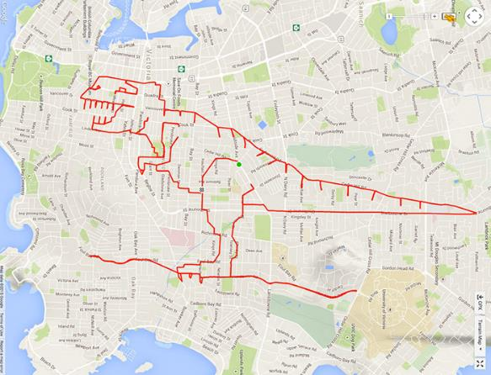

* What we’re going to try today is a little bit like this picture… 😊  
  And these guys took their measuring very seriously!
  + Details: <https://medium.com/@importanttech/we-tested-mobile-gps-gnss-accuracy-and-found-some-surprising-results-b9ec35873e2e>

1. A group of sausages on a black background

   AI-generated content may be incorrect.Activity Flow

6.1. Introduction

* Start with discussion questions to spark conversation:
  1. Can you remember what we did last time?
  2. Did you enjoy the activities in our last session?
  3. After doing all those measurements and calculations inside the classroom, what do you think the next step is? What do you think we’ll be doing today?
  4. Did you do your homework?
* 2. Then, explain what pupils will be doing in this lesson (if appropriate, show a slide with today’s learning goals in pupil-friendly language.)



6.2 Different Methods of Data Collection (Review of the Session 1)

In the first part of the second session, we’ll revisit the methods used in the first session, as we’ll be applying them today in practice, outdoors.

1. Ask pupils:
   1. What three methods did we use to count steps? (Answer: manual counting; step counter on a mobile phone; smartwatch/fitness tracker on the wrist)
   2. **EXTRA**: What different ways did we use to measure distance?

(Answer: laser, measuring tape, manual counting, phone step counter, pedometer)

* 1. Did these methods give us similar results? In what ways were they different?
  2. What were the good and bad points of each method?
  3. What could each method be used for?
  4. Are there any special things we need to keep in mind when using each method?
  5. So how did we calculate the distance in the end?
  6. How did you complete the homework?
     1. What measurement methods did you use?
     2. Were there any differences in the results?
     3. Which method of measurement did you like best? Why?

6.3 Online Tools for Measuring Distance (in-class activity)

The success of a measurement method depends on what you want to measure. If your aim is simply to count your steps, then—for shorter distances—manual step counting works well. However, for longer distances, it's easy to lose track. Using a device to count steps works well over greater distances, but not everyone has access to a mobile phone or smartwatch. There are other methods for measuring distance that work best outdoors—in streets, parks, and open spaces. *(In Workshop 2, we also created and used maps to find the missing teacher.)*  
Maps can also be used to measure distances between points. There are online tools you can use for this, and we will be introducing *Google Maps*.

Depending on your context, your pupils’ concentration levels, and their prior knowledge of Google Maps, you can decide at what point to ask pupils to use their mobile phones:

**Option 1**: Ask pupils to take out their mobile phones only after all explanations   
have been given and once you are outside.

**Option 2**: Give all explanations without using mobile phones,   
then allow pupils time to practise using the maps in the classroom.

**Option 3**: Invite pupils to take out their mobile phones   
and explore the maps while you give instructions.

**PLEASE NOTE**: Measuring distance on a mobile phone is simple, but pupils may need time to get used to it. We recommend practising this in the classroom first (Options 2 or 3), as pupils are likely to be more focused indoors than once outside.

1. Show *Google Maps* app and its “Measure distance” tool on a **computer**.
   1. Open the website [maps.google.com](https://maps.google.com).
   2. On the map, locate the outdoor area where the measurement will take place.
   3. Measure the distance using the *Measure distance* tool:
      1. Right-click on your starting point and select “*Measure distance*”.
      2. Continue clicking with the left mouse button to add points and extend the measurement.  
         If you make a mistake, click the point again to remove it.
      3. Finish measuring by clicking the final point and check the total measured distance.

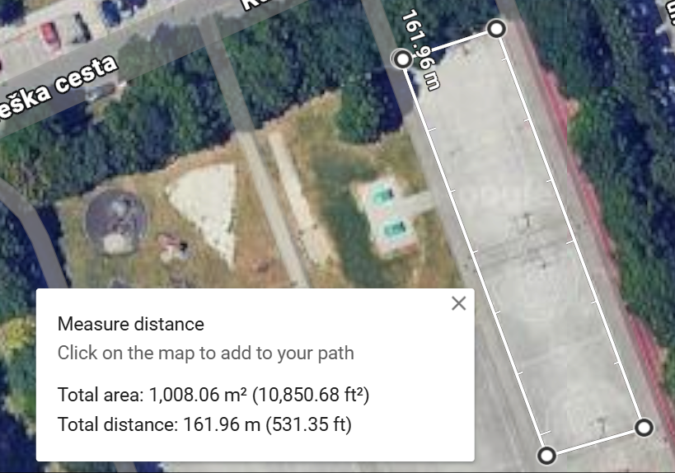

1. Show *Google Maps* app and its "*Measure distance*" tool on a **mobile phone**. You can use prepared screenshots for a projector display or do a live demonstration on your own phone.
   1. Open the *Maps* app on your mobile phone.
   2. Press and hold on the desired location (the starting measurement point) on the screen.
   3. Open the menu that appears.
   4. Select the "Measure distance" option.
   5. Drag your finger to move the screen – you will see the next point move along with a blue line marking the route.
   6. When you are ready for the next point, tap the “+” or “Add point” button.
   7. Repeat this process until you reach the final point.
   8. Finish the measurement by tapping the last point and check the total distance value.

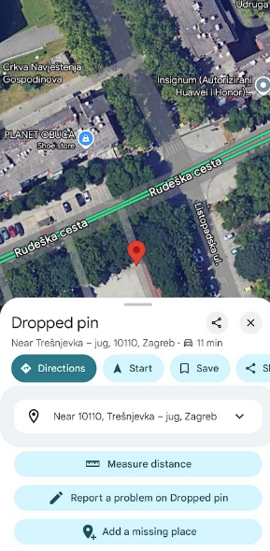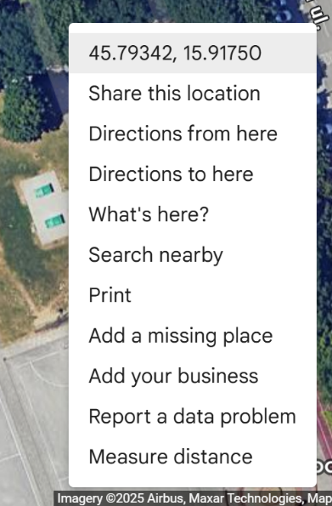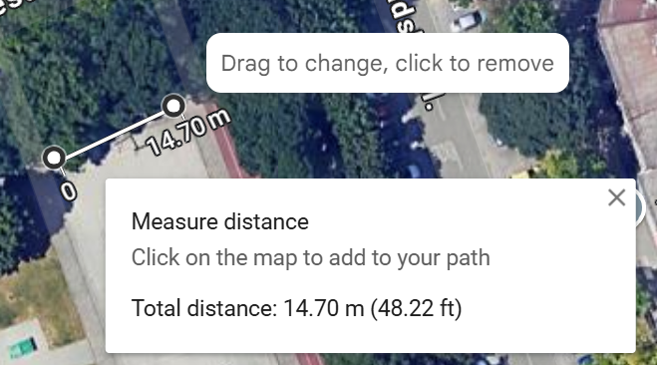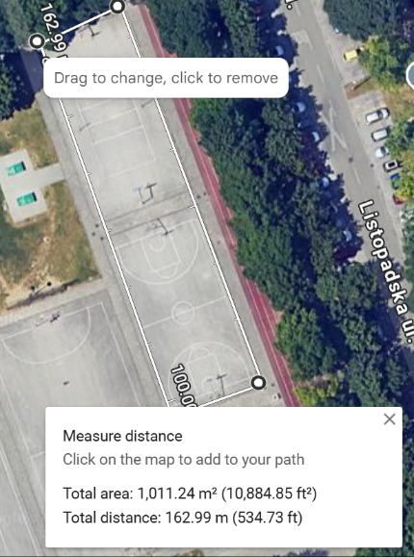

1. Highlight the following points:
   1. There is a difference between measuring the shortest distance between two points and fine-tuning the measurement by adding more points for a more detailed route.
   2. The "*Measure distance*" tools can sometimes be more practical than using the driving directions feature in these apps, which often "snap" the route to nearby roads; the measuring tools work particularly well for longer routes.
   3. We need to be very careful when selecting points, as entering inaccurate points will result in inaccurate distances.

6.4 Using Satellites to Help Us (in-class activity)

Before we start measuring distances, we’ll briefly introduce a big story: what do the **satellites in the sky** have to do with measuring distances around the school?

**PLEASE NOTE:** Depending on the teacher’s knowledge, you can give a longer or shorter introduction to satellites and GPS. The link below (*in English*) provides a quick and simple introduction to the topic. Also, the attached short NASA video explains everything in a child-friendly way. So, you can just say a few sentences:

* Around 30 navigation satellites orbit the Earth very high up (about 20,000 km altitude).
* They send signals to the Earth and form the **Global Positioning System (GPS)**.
* Every device we use that relies on GPS or Galileo (*the European system similar to the American GPS*) must know the position of at least 4 satellites. Based on the satellites’ positions, the GPS receiver in our device calculates our geographic location. The more satellites we “see”, the more accurate our location can be.
* Various obstacles can make our results less accurate: clouds, bad weather, nearby buildings (narrow streets), being indoors, and so on.

1. As we saw in Workshop 2, every location or object in the world can be precisely described by some “coordinates” on a map. But we can also know **our current location**, recorded as similar coordinates. This is where the satellites in the sky come into play. 😊
   1. Satellites / GPS – a simple explanation here: <https://spaceplace.nasa.gov/gps/en/> .
   2. NASA video on how GPS works – <https://www.youtube.com/watch?v=RSA3feQ9gKk>
2. Besides knowing where we are, we can also **record (save) the path we travelled** – a set of points/locations showing how we moved from the start to the end of our recorded route. This allows us to do interesting things, like displaying our journeys on a map, measuring distances, or planning walking routes for our holidays. There are different ways to store this journey, but we will use **GPX** because it is a generic format understood by all devices. So, we can record our journey using any compatible device such as a mobile phone or a smartwatch and then send this GPX file somewhere else to view or analyse it.

**PLEASE NOTE**: Depending on your context, you can choose how to organise GPX track recording. Based on your choice, you may provide a longer or shorter explanation and demonstration.

**Option 1**: GPX tracks will be recorded by walking with the teacher’s mobile phone. This is a simpler choice because nothing needs to be installed beforehand on the pupils’ phones, the routes can be easily shared, and there will be fewer technical issues. Pupils would just need to walk without any setup. On the other hand, this means pupils will hold the teacher’s phone for a few minutes, so choose responsible pupils for this task. We recommend this option.

**Option 2**: GPX tracks will be recorded by walking with several pupils’ phones. This means the GPX recording app must be installed in advance (with parental supervision), pupils must have a way to send their track files to a location accessible on a computer connected to a projector/screen, and pupils must know how to use the app. This process will take quite a while. We recommend this option only if you have several pupils (and parents)  
who are comfortable with computers and smartphones.

The following points describe how to use the recommended **GPX track recording app** on *Android* devices. Depending on how you choose to involve the pupils, you may skip the details and simply explain what we will do outside.

1. The recommended app (for Android devices) is GPS Logger:
   1. <https://play.google.com/store/apps/details?id=eu.basicairdata.graziano.gpslogger>
   2. It is a simple app for recording tracks. It supports manual export/sharing of recordings via e-mail, *WhatsApp*, etc.
   3. Download and install the app on your mobile phone.
2. Open the app and wait a few seconds until it establishes a GPS connection and shows your geographic coordinates (latitude and longitude).
3. Go to your chosen location, the starting point for recording.
4. Press the "*Record*" button in the bottom menu.
5. Walk the route holding the phone in front of you. Walk steadily, without waving your arms, in a straight and precise manner.
6. When you reach your destination, press the "*Stop*" button in the bottom menu.
7. Enter a name for your track.
8. You can find your recorded GPX track in the track list in the top menu.
9. Check the details and thumbnail of the recording — was the recording successful?
10. Export the track.

**PLEASE NOTE**: Choose the export method that suits you. The goal is to send the file to a computer whose screen is displayed in the classroom. You can e-mail the track to yourself, upload it to an available file-sharing service, or send it via a messaging app. If you use *WhatsApp*, we recommend sending it to yourself (or the class group, if available), so you can then access it on the *WhatsApp* app, desktop, or web version. Be sure to test this export in advance to reduce stress during the pupils’ outdoor research and speed up the process!

1. Tap the track you want to export and click the “*Share*” button in the top menu.
2. Choose the sharing app (for example, *WhatsApp*). Select the contact (e.g., “You – send message to yourself”). Two files, .KML and .GPX, will be exported and sent.

The import process is described later in the document.

Explain to the pupils the questions about **GPS accuracy**:

1. We are currently in the classroom, so recording now doesn’t make much sense because we have trouble “seeing” the satellites anyway. But next time you are outside, just look up — can you see the satellites? Of course not, because they orbit about 20,000 kilometres above the Earth. The satellites send out signals that travel to us, and we use those signals to determine our position. But:
   1. Do you think when we go outside the GPS will know our “exact” location, down to a few centimetres?
   2. Is it possible that some points are very inaccurate?
2. Explain that this recorded track sometimes has errors — not every recorded location is accurate. After recording, we could check the GPX track and see if it needs correcting to be more useful before we display or measure anything.
3. Also, this technology has its own accuracy limits — it cannot pinpoint you exactly to the centimetre, and sometimes not even to a few metres. Many factors influence accuracy. Beyond technical aspects, understand that satellite signals travel a long distance and many things can affect this journey. For example, it matters whether it’s a clear or cloudy day because clouds can scatter the signals. Or whether you are in an open space or surrounded by tall buildings or trees. Even overhead tram wires can affect GPS signal accuracy.

6.5 Real-Life Research and Comparison of Methods (outdoor and in-class activity)

As the final step of this workshop, **we will go outside and test all these methods in a real-world environment.**

**PLEASE NOTE**: This is the most important and challenging part of the workshop, as pupils will be using different measurement methods, mobile phones may distract them, activities take place outdoors, and so on. Be prepared to handle various situations and remain flexible. You can choose from several options for conducting this activity.

Also, it would be helpful to have an assistant to support you outdoors, helping with questions, discipline, technology, and preparing results. However, we have successfully run this activity with just one leader as well.

6.5.1 Group Organisation

At the start of the activity, **pupils should be divided into groups, each using different methods for measuring distance**. First, decide which methods you will use.

**Option 1:** Use all 5 methods (recommended, but requires more organisation and attention):

* 1. Manual step counting
  2. Step counting using a mobile phone
  3. Step counting using a smartwatch / fitness tracker
  4. Measuring distance with online tools on mobile phones
  5. Measuring distance by recording a GPX track

**Option 2**: Reduce the number of methods to suit your context. For example:

* Method d), “online tools on mobile phones,” can be done by the teacher   
  in the classroom as it doesn’t depend on GPS.
* Method a), “manual step counting,” might be tedious for pupils.
* Method e), “recording a GPX track,” is very useful and recommended but requires more technical knowledge and some practice.

**Option 3**: Methods a), b), and c) were already partly covered in the first session indoors. Although we recommend using them outside as well, if you need a really short version, you can focus only on methods d) and e).

You should also decide when and how to organise the groups.

**PLEASE NOTE**: We recommend providing as much information as possible while still in the classroom, including dividing the pupils into groups there. Pupils tend to be more focused in the classroom than outside. This is especially important if you have more than 10 pupils or if they are in the lower year groups.

**Option 1**: Assign each pupil to one group, i.e., one method.  
We recommend this option. Start with the most specific groups:

* If you choose to record GPX tracks on pupils’ phones ->
  + assign those pupils to group e).
* Ask who has a smartwatch ->
  + assign them to group c) for step counting using a smartwatch.
* Ask who has a phone with internet access ->
  + assign them to group d) for measuring distance using the Google Maps app.
* Ask who has a phone WITHOUT internet access ->
  + assign them to group b) to count steps using their phone.
* Pupils who remain should be those without a phone or smartwatch.
* Ask who wants to record a GPX track or choose more responsible pupils yourself ->
  + assign them to group e), recording with the teacher’s phone.
* The other pupils should walk while counting steps manually.

**PLEASE NOTE**: If some categories have too many pupils (for example, phones with internet access), you can assign some to another suitable group.  
We recommend you write down immediately which pupil is in which group to reduce stress later.

**Option 2**: If your context is different, you may need to work with one method at a time and “direct” pupils on what to do; strict grouping of pupils is less important   
(or grouping at all).

6.5.2 Going Outdoors

1. Choose a safe walking route whose length you will measure/calculate. The route should be neither too short nor too long, and not too winding (a few bends are fine, even desirable). The length should be at least 200 metres. Clearly mark the start and finish points (it is recommended to choose a landmark visible on the map). Scout the area beforehand so you’re prepared on the day of the activity.
2. **Each group will carry out its own measurement/calculation research. Within the group, each pupil should conduct their own experiment, as we will compare results both within and between groups.** It is also advised that not all pupils measure at once, especially not pupils from the same group, as this could disrupt their natural walking pace. Send them out one by one, with about a 1-minute interval.
3. Measurements should be carried out as follows:
   1. **Manual step counting** – walk with your normal stride, don’t run. Count your steps and write down or report the number.

**EXTRA**: In the classroom, also calculate step length and distance using the formula for men (height * 0.415) and women (height * 0.413), then multiply by the number of steps. However, it’s easier if the teacher does this during the analysis phase.

* 1. **Step counting using a mobile phone** – open the step counting app. Write down or report the starting step count. Begin walking with your normal stride, don’t run. After finishing, wait without moving for about 10 seconds until the number changes and stabilises. Write down or report the final step count.

**EXTRA**: Calculate and write down or report the number of steps taken. It’s easier if the teacher does this during analysis.

**EXTRA**: Some pupils can experiment by holding the phone still in their hands or in a pocket, or by waving their hand more than usual, etc.

* 1. **Step counting using a smart watch / fitness tracker** – write down or report the starting step count. Begin walking with your normal stride, don’t run. After finishing, wait without moving for about 10 seconds until the number changes and stabilises. Write down or report the final step count.

**EXTRA**: Calculate and write down or report the number of steps taken. It’s easier if the teacher does this during analysis.

**EXTRA**: Some pupils can experiment by keeping their arm quite still in one place or waving their arm more than usual, etc.

* 1. **Measuring distance using online tools on mobile phones** – *the phone must be connected to the Internet (data usage applies!)*. Open the *Google Maps* app and tap the target icon to get your current location (blue dot). Check if the location is accurate (within a few metres). Long-press your location, pull up the menu and tap “*Measure distance*”. Start walking, tracking your location. If the route has bends, add points so the path follows your steps. When you reach the end, add the final point. Write down or report the distance.
  2. **Measuring distance by recording a GPX track** – open the GPX recording app (see above). Check if the GPS signal is available — i.e., if your location is visible. Start recording and begin walking. When you reach the end of the route, stop recording.

1. Nakon što su svi eksperimenti obavljeni i svi rezultati prijavljeni/zapisani, vratite se u učionicu.

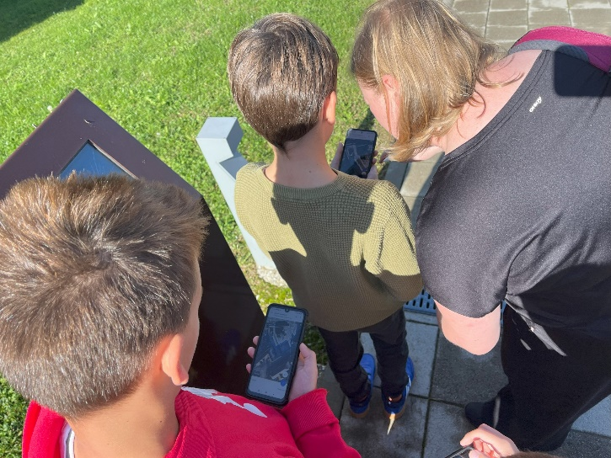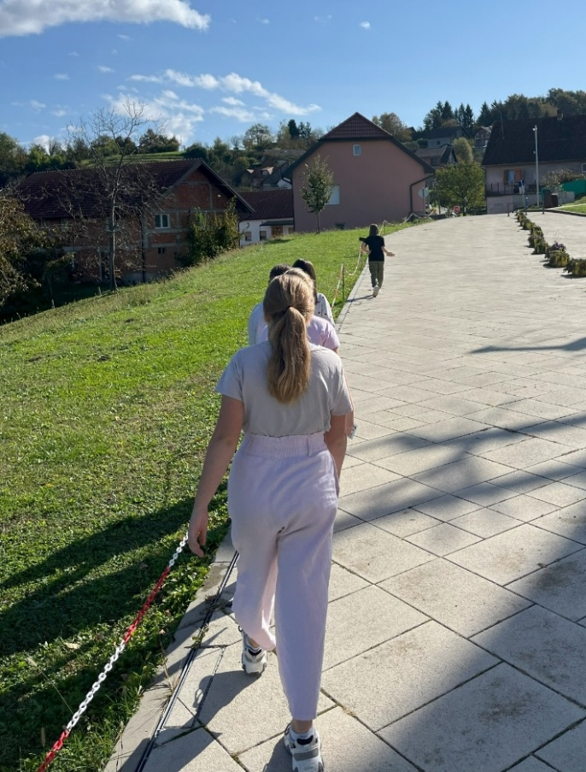

**PLEASE NOTE:** You can organise writing/reporting results in several ways:

**Option 1**: Give each pupil a slip of paper to write down their data (results, starting/ending step counts, etc.). Later, you will need to transfer the results onto a shared sheet or enter them into a spreadsheet on a computer.  
**Option 2**: Have each pupil report their results to you immediately after finishing – we recommend this option. Write the data on a shared sheet of paper. Later, you can copy the data into a spreadsheet or simply analyse it from the paper.  
A template is available on our website.  
**Option 3**: Enter the data directly into a spreadsheet right away. This might not be advisable, as it requires several conditions — an internet connection,   
no rain, no strong sunlight, and you need to type quickly on a mobile device, etc.

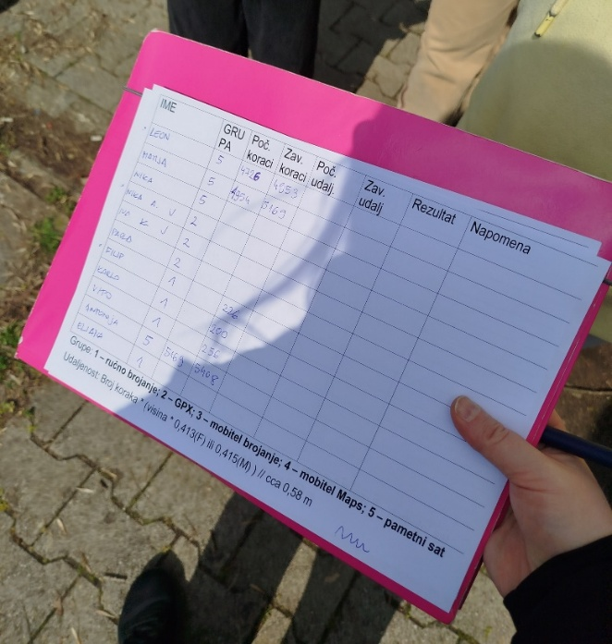

6.5.3 Preparing Results in the Classroom

After you return to the classroom, **prepare the results:**

**Option 1**: Use only the paper sheet with the data, without computer-based analysis. Calculate the data (subtract final – initial steps, calculate distance from step count, etc.) if the pupils haven’t done so already.

**Option 2**: Copy the data into a spreadsheet to calculate results, create graphs, and so on.

**Option 3**: Alternatively, an online form can be prepared where each pupil enters the distance, method used, and additional notes about the measurement. This is the slowest option.

1. Ask the pupils (in their groups) about their results and experiences.
2. Organise the results as preferred, making sure to indicate the method used for each result.
3. Present all results in the form of tables or charts, or simply discuss them, briefly highlighting the differences – both between pupils in the same group and across different groups.

**The GPX track recording** method should be presented separately. Transfer the tracks from the phones that recorded them and import them into a platform such as *Google My Maps* using the following steps (you can import multiple tracks onto a single map):

1. Locate the GPX files that were sent from the mobile phones using your preferred method (email, file sharing, messaging app). Save them to your computer (if not already saved).
2. Open <https://mymaps.google.com> (a *Google* account is required to import files).
3. Click the "*Create*" button in the bottom right corner.
4. Click the "*Import*" link.
5. Select your GPX file. (*When exporting, a second file with a .kml extension may also be sent. You can use this as well; these are two different formats for the same purpose.*)
6. The GPX track should appear on the screen.
7. If you click on the track, you can view track details, including the calculated distance.
8. To add more tracks, click "*Add layer*" and repeat the process.
9. You can change the track colour by clicking the colour fill icon next to the track name.
10. The final map should show all the tracks, each with its respective distance.

6.6 Analysis and Discussion

Discuss what the pupils have learned, depending on the results, with the suggested questions:

1. Why do you think there were differences within each group and between different groups?
2. Which result is the most accurate? What kinds of errors can you identify in a method?
3. Did you trip or stumble if you were walking while looking at your phone? Would that affect your measurements?
4. When using the GPX track recording app, were you near:  
   a. Tall buildings or under trees?  
   b. Overhead tram wires or high-voltage power lines?  
   c. Was the sky clear or cloudy?
5. So, in the end – which results are actually accurate? :-)
6. How do we know if a method is fit for purpose? We could spend a lot of time trying to get the “most precise” results by using all sorts of technology, even satellites, tweaking recorded tracks, and so on… But is it “worth the effort”?  
   Perhaps, or perhaps not – it depends on what you need. You should always think critically about what you're trying to achieve, how accurate your results need to be, which method might be appropriate, and how much time and “money” (equipment, preparation, resources, etc.) it will require.
7. Can you trust the results? It depends. All these methods are “correct”, but there will always be some errors. It’s unwise to blindly trust a single number – it could mislead you. Always double-check and be aware of how that number came to be – because that’s closely linked to its accuracy.
8. Why should I care about accuracy? Heh. 😊 Good question.  
   If you’re building a house, you’ll probably care about exact measurements. If you’re training for running or cycling, you’ll likely want to record your route precisely to check how far and how fast you went.  
   But is it still relevant if you’re an athlete training only on a short track?  
   If you want to know where you went and how fast you walked while hiking through a beautiful location on holiday, you probably *would* want to know the route and distance. But do you need to track every trip to and from your house?  
   Some things matter, some don’t – and that’s something you also need to learn in life.

6.7 Conclusion and Deepening

End the session with the following questions:

1. What did you learn today? What did you enjoy the most, and what you didn’t like?
2. What would you tell your parents about what you did today?
3. What did we find out today?  
   Allow pupils to share their own conclusions.
4. Did we expect these results?

Let pupils respond with their own thoughts. If needed, ask: Why do you think there are differences?

1. The teacher can briefly summarise what they’ve learned today — were there any surprises?

In this lesson, pupils used different methods and devices to measure short distances outdoors. They will notice that using various methods and devices over relatively short distances produces different results. By discussing these differences, pupils will learn that each method and sensor has its limitations depending on the circumstances. They will critically assess how different methods affect data quality. It seems that sensor devices are generally accurate in principle, but – especially over shorter distances – they are not always precise due to factors such as the delay in starting measurement, the position of the device, and the scattering of satellite signals caused by weather conditions, nearby trees, tall buildings, or overhead high-voltage lines and tram wires.

Co-funded by the European Union. Views and opinions expressed are however those of the author(s) only and do not necessarily reflect those of the European Union or the European Education and Culture Executive Agency (EACEA). Neither the European Union nor EACEA can be held responsible for them.   
[[Erasmus+ Project 2023-1-NL01-KA210-SCH-000157821 DIgital data-dRiven EduCaTion fOR kidS](https://erasmus-plus.ec.europa.eu/projects/search/details/2023-1-NL01-KA210-SCH-000157821)]

The **DIRECTORS (DIgital data-dRiven EduCaTion fOR kidS)** project is carried out by partners from Delft University of Technology (The Netherlands) and the University of Zagreb (Croatia) as part of the Erasmus+ programme, co-funded by the European Commission.

Our goal is to **promote data literacy in primary education** through new teaching methods and materials. We aim to support the updating of existing curricula related to data education, with the goal of enhancing digital and data skills among **teachers and pupils**.

These open educational resources are the result of the DIRECTORS project’s commitment to strengthening data literacy among young primary school pupils, offering **practical and age-appropriate** open content designed for both teachers and learners.

[**www.kidsdirectors.eu**](http://www.kidsdirectors.eu)